**PROJECT DOCUMENTATION**

**Exploratory Data Analysis**

Laptop Specs DataSet

**Name :** Nivash C

**Course :** Data Analytics

**Batch Number :** 26

**Mode of Study :** Offline

**Roll Number :** 160324CBR004

**Table of Contents**

1. Introduction

2. Aim

3. Business Problem / Problem Statement

4. Project Workflow

5. Data Understanding

6. Data Cleaning - Missing Values Imputation, Outliers, Handling Inconsistent

Values

7. Obtaining Derived Metrics

8. EDA - Univariate Analysis

9. Segmented Univariate Analysis

10. Bivariate Analysis

11. Multivariate Analysis

12. Overall Insights Obtained from Analysis

13. Conclusion

**1. Introduction**

The purpose of this project is to perform an Exploratory Data Analysis (EDA) on Laptop Characteristics Dataset to uncover underlying patterns, relationships, and insights. The dataset includes information on the laptop dataset comprises various attributes related to laptops, including manufacturer, specifications, and pricing information.

­­­

**2. Aim**

The goal of this project is to conduct a comprehensive analysis of the dataset to derive insights into laptop characteristics, performance, and pricing,catering to both consumers and manufacturers in the computer industry**.**

**3. Business Problem / Problem Statement**

The laptop market is highly competitive, with a diverse range of products differing in specifications, performance, and pricing. Consumers often struggle to choose the most suitable laptop due to the vast array of options, while manufacturers need to understand market trends to optimize their offerings. By analyzing a comprehensive dataset that includes various attributes related to laptops, such as manufacturer details, specifications, and pricing.

**4. Project Workflow**

The project workflow includes the following steps:

1. Data Collection
2. Data Cleaning and Preprocessing
3. Exploratory Data Analysis
4. Data Visualization
5. Deriving Insights
6. Reporting

**5. Data Understanding**

The dataset consists of 1303 rows and 12 columns.

The key variables include

* Company
* Inches
* Ram
* OpSys
* Weight
* Price

Data Types

* Object-Other than ‘Price’
* Float-‘Price’ and ‘Inches’

**6.Data Cleaning**

Data cleaning involved:

* Dropping null values:

Since there are more null values rows present.So,dropping it.

* Dropping unwanted columns;

There is a column ‘Unnamed: 0’ which is not necessary for the analysis.So,removing it.

* Imputing missing values using mode method:

There are more number of missing values in columns ['Inches','Ram','Weight'’].So, imputing it using the mode method.

* Replacing the inconsistent entries with mode values:

There are inconsistents in the columns [‘Inches’,’Weight’].So, replacing it with the corresponding mode values.

* Typecasting three variables from object to int and float:

Typecasting the ‘Inches’ column from object to Float.Typecasting the ‘Ram’column from object to Int.Typecasting the ‘Weight’ column from object to Float.

* Identifying and treating outliers using quantile method:

Treating the outliers in the columns [‘Inches’,’Ram’,’Weight’,’Price’] using the quantile method.

**7. Obtaining derived metrics**

Extracted the ‘Cpu_manufacturer’ from the column ‘Cpu’ to get the overall insight based on the cpu manufacturers.And using it to find various insights from this data.

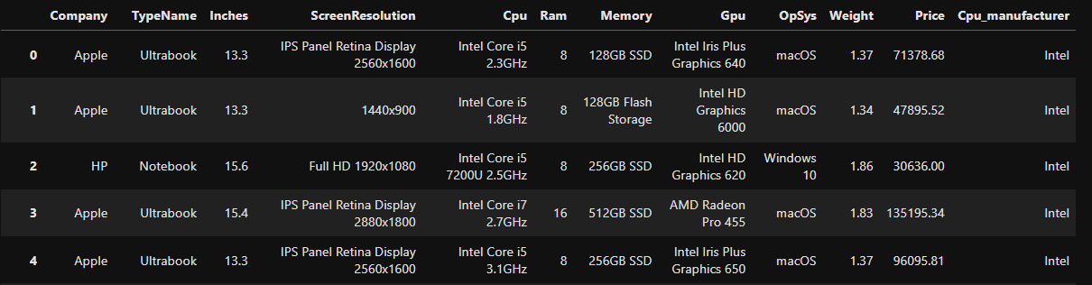

**8. EDA - Univariate Analysis**

Univariate Analysis revealed:

**1**.Screen size distribution:

It implies that the **laptop screen size** in the range of about **16 inches** having the **more**.

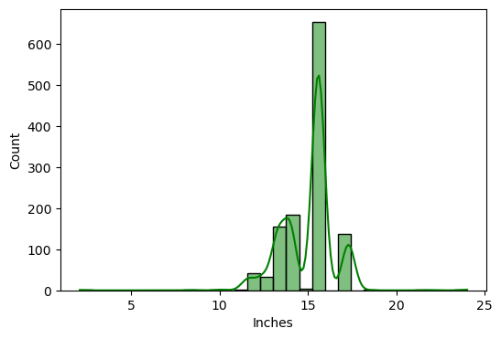

**2.**. Ram distribution:

It implies that **8GB Ram** has the **more number of units** sold.

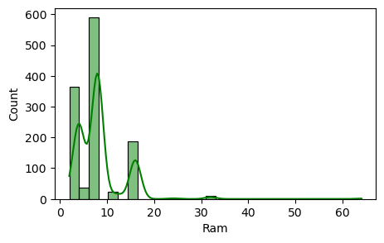

**3.**.Weight distribution:

It implies that the **average of Weight** range from **1.8 to 2.2** having more distribution.

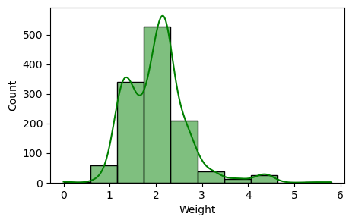

**4.**.Price distribution:

From this we can infer that from **low to mid range** of price has more number of values and when the price is increasing,the number of values decresing.

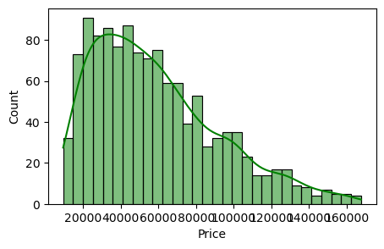

**9. Segmented Univariate Analysis**

Segmented analysis showed:

**1.**’Company’-based analysis:

Comparing the ‘Ram’ of whole dataset that is based on ‘Company’.

**Inference:**

From the above analysis,it is noted that the companies 'Razer' and 'MSI' are average selling high end Ram devices.

**2.’**Cpu_manufcturer’-based analysis:

Identifying the trend between the ‘Ram’ and ‘Weight’ based on the CPU manufacturers.

**Inference:**

From this, we can say that the **Intel** had producing the Ram beyond 16GB and also the laptop having **Intel 32GB Ram** having the more weight.

**10. Bivariate Analysis**

Bivariate analysis included:

**1.**’Ram’ vs ‘Price’:

Comparing the prices of different ram devices.

**Inference :**

In the price range of **1,36,000 to 1,52,000**, there is a **higher concentration of laptops** with various RAM configurations.

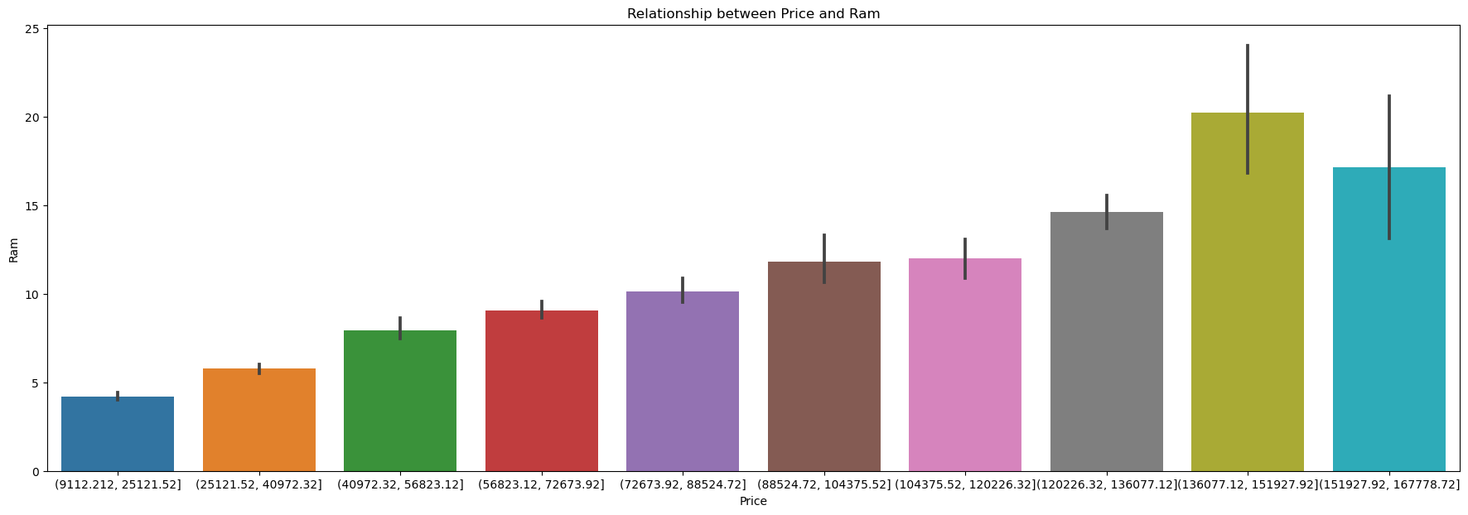

**2.**’OpSys’ vs ‘Price’:

Comparing the prices of different devices having different operating systems.

**Inference :**

From this we can say that **'MacOS'** costs more than any other OS.

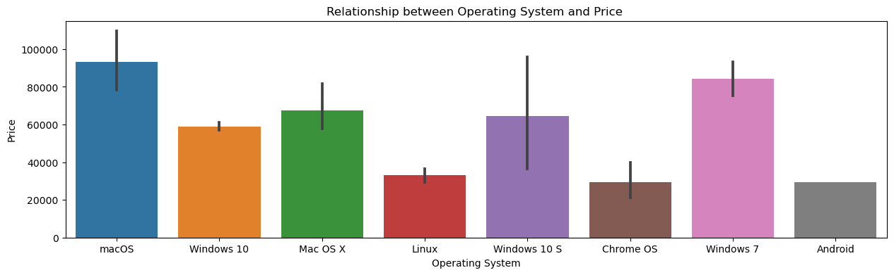

**3.**’Inches’ vs ‘Weight’:

Comparing the weight of the devices based on the screeen size of the devices.

**Inference :**

It is noted that laptops having screen size around **18.4 inches** having **more weight.**

**11. Multivariate Analysis**

Multivariate analysis revealed:

**1.**Analysis based on companies:

Comparing the relationship between different variables based on the companies available.

**Inference:**

From this we can infer that the companies such as **Apple,HP,Acer,Asus,Lenovo,Dell** having the majority when it comes all of the whole.

**12. Overall Insights Obtained from Analysis**

Based on the inferences drawn from your data exploration and visualization, here's a detailed analysis and interpretation of the findings, along with recommendations for the laptop market:

**Analysis and Interpretation**

**Key Factors Influencing Laptop Pricing and Consumer Preferences:**

1. Screen Size Preferences:

- Laptops with screen sizes around 16 inches are highly popular. This suggests a consumer preference for medium to large screens, which likely offer a balance between portability and viewing comfort.

2. RAM Configuration:

- Laptops with 8GB RAM are the most prevalent, indicating that 8GB is the sweet spot for most consumers, offering adequate performance for general use without significantly increasing costs.

3. Weight Distribution:

- The majority of laptops fall within the weight range of 1.8 to 2.2 kg. This weight range strikes a balance between portability and durability, catering to users who need to carry their laptops frequently.

4. Price Distribution:

- The data shows a higher number of laptops in the low to mid-price range, with a sharp decline in units as the price increases. This indicates that the majority of consumers are looking for budget to mid-range laptops, which offer good value for money.

5. High-End Price Range:

- In the price range of ₹1,36,000 to ₹1,52,000, there is a variety of laptops with different RAM configurations. This suggests that in the high-end segment, consumers are looking for premium features and are willing to pay more for higher specifications.

6. Operating System Cost:

- Laptops with MacOS are generally more expensive than those with other operating systems. This could be due to the brand value and the perceived premium quality associated with Apple products.

7. Brand Influence on Pricing:

- Brands like Apple, MSI, Samsung, Google, and Razer command higher prices. This reflects the brand reputation and the premium consumers are willing to pay for perceived quality, innovation, and status.

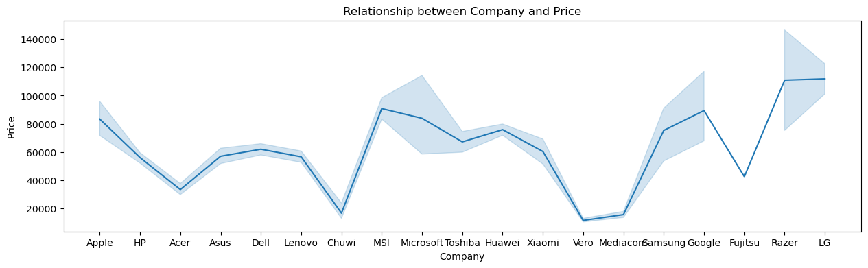

8. Processor Dominance:

- Intel processors are widely used across various laptop models, indicating a strong market presence and consumer trust in Intel’s performance and reliability.

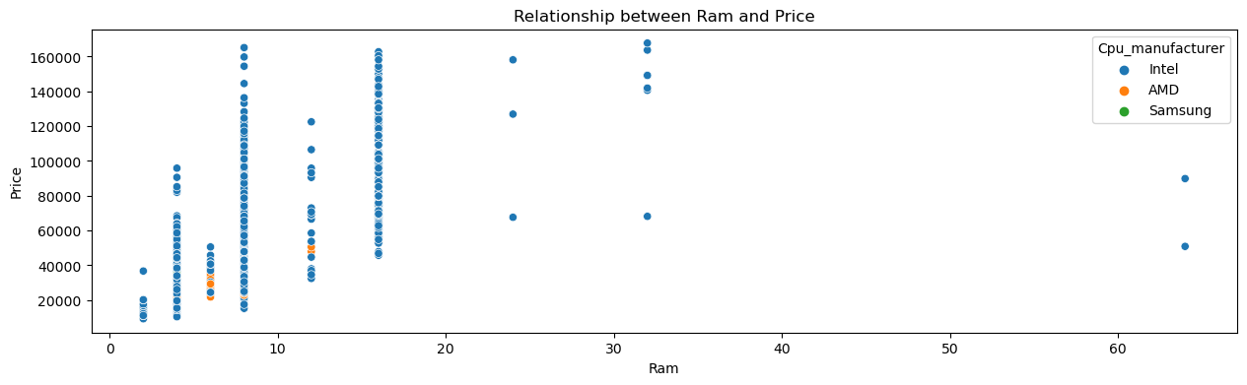

9. Price Central Tendency:

- The central value of the dataset is around ₹50,000, with most prices falling between ₹30,000 and ₹80,000. This suggests that the bulk of the market activity is concentrated in this range, making it a highly competitive segment.

10. RAM and Price Correlation:

- There is a high correlation between RAM size and price, meaning that as RAM increases, the price tends to increase as well. This highlights the importance of RAM as a key factor in determining laptop prices.

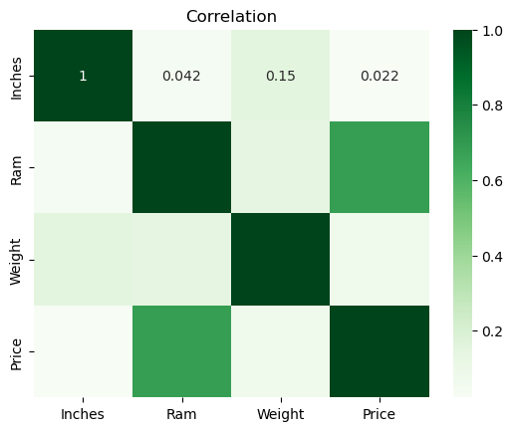

**Recommendations**:

**Product Differentiation:**

1. Expand Mid-Range Offerings:

- Given the popularity of the mid-range price segment, manufacturers should focus on expanding their offerings in this category with enhanced features that appeal to budget-conscious consumers.

2. Innovate in Screen Size and Weight:

- Consider developing ultra-light laptops with medium to large screen sizes (around 16 inches) to cater to the demand for portability without sacrificing screen real estate.

**Marketing Strategies:**

1. Highlight Key Specifications:

- Emphasize the most popular and sought-after features such as 8GB RAM, medium screen sizes, and optimal weight in marketing campaigns to attract the majority of consumers.

2. Promote Brand Strength:

- For premium brands like Apple, MSI, and others, highlight the unique selling points such as advanced technology, superior build quality, and brand prestige to justify the higher prices.

**Pricing Adjustments:**

1. Competitive Pricing for High-End Laptops:

- In the high-end segment, offer competitive pricing strategies and bundle deals (e.g., accessories, extended warranties) to attract consumers who are willing to invest in premium models.

2. Flexible Pricing Models:

- Consider offering financing options or trade-in programs to make higher-priced laptops more accessible to a broader audience.

**13. Conclusion**

The analysis of the laptop market data reveals significant insights into consumer preferences and pricing dynamics. By focusing on popular configurations, leveraging brand reputation, and employing strategic pricing and marketing tactics, manufacturers can better meet consumer needs and enhance their market position.